**MWS Pod**

**Statement of work**

Index

1. Scope 2

1.1 Identification 2

1.2 System overview 2

1.3 Document overview 3

2. Requirements 3

2.1 Functional requirements 3

2.1 Performance requirements 4

2.2 Environment requirements 4

2.3 Interface requirements 4

**History**

|  |  |  |  |
| --- | --- | --- | --- |
| **Date** | **Description** | **Name** | **Version** |
| 21-09-2010 | Initial document | kpi | 1.0 |

**Abbreviations**

|  |  |
| --- | --- |
| UR | User Requirement |
| SOW | Statement of work |
| UFR | User Functional REQ |
| UPR | User Performance REQ |
| UIR | User Interface REQ |
| UER | User Environment REQ |
| TBD | To Be Determined |
| TBR | To Be Reviewed |
| TBS | To Be Supplied - Awaiting input |
| MWS | Missile Warning System |

# Scope

## Identification

The system to which this document applies is a pod that can be attached to the F-16 combat aircraft using standard T-hooks spaced by 13 inches.

The dimensions and shape of the system shall be defined by manufacturer and shall be in compliance with the FP42f standard.

The pod has three compartments for chaff/flare magazines. Two compartments hold two magazines each and one compartment holds four magazines.

It houses an electronic control unit and has suspensions for power/data cable harness, connectors and six sensor units which covers all angles not shaded by the aircraft seen from the pod.

The manufacturer shall identify the placement of the six sensors.

The system is able to keep the temperature of the MWS inside the pod below 70 degree Celsius.

The pod structure and attachments is able to withstand high g-forces and high temperatures especially on the front part and still be operational.

All requirements are verified by subcontractor.

## System overview

The pod is part of a self protection suite for the F-16 combat aircraft. The system is made up of subsystems which are:

* An cockpit control unit.
* A missile warning system (MWS) consisting of six sensor and an electronic control unit.
* A pod which incorporates eight magazines, six sensors and housing the MWS.

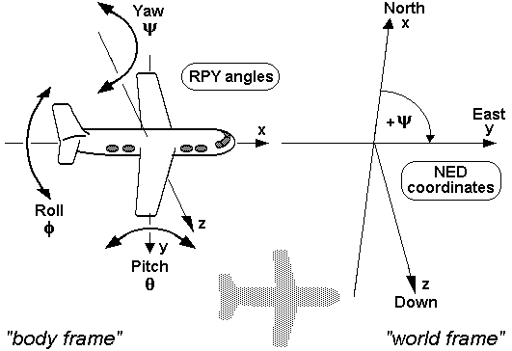

**Figure 1.** The figure illustrates how angles are represented relative to the aircraft. Left and down is positive. RPY: Roll, Pitch, Yaw; NED: North, East, Down.

## Document overview

|  |  |  |
| --- | --- | --- |
| Ref-1 | Therma case.pdf | Version 1 |

# Requirements

## Functional requirements

|  |  |
| --- | --- |
| UFR-1 | The weight of the pod structure shall not exceed 175 Kg. Harness not included |
| UFR-2 | The pod shall have Three compartments for dispenser magazines. |
| UFR-3 | The pod shall have one compartment for two magazines facing forward.  Ψ = 15⁰ φ = 15⁰ θ = 15⁰. Se figure 1. |
| UFR-4 | The pod shall have one compartment for four magazines facing sideward.  Ψ = 90⁰ φ = 15⁰. Se figure 1. |
| UFR-5 | The pod shall have one compartment for two magazines facing downwards.  φ = 90⁰ θ = 90⁰. Se figure 1. |
| UFR-6 | The dimensions of the pod shall comply to the standard FP42f |
| UFR-7 | The system shall include a hardware implemented safety switch to prevent dispensing on ground. |
| UFR-8 | The hardware safety switch shall be operated with a safety pin. |
| UFR-9 | The safety pin shall be clearly labeled and accessible by aircraft maintenance crew as specified by the aircraft maintenance manual *AMM32f*. |
| UFR-10 | All electrical connections shall be accessible from the outside to ease the attachment of the pod to the aircraft and for testing on ground when not attached. |

## Performance requirements

|  |  |
| --- | --- |
| UPR-1 | The pod structure shall be without any failures after being exposed to a steady state acceleration of 5g fore. |
| UPR-2 | The pod structure shall be without any failures after being exposed to a steady state acceleration of 2.5g aft. |
| UPR-3 | The pod structure shall be without any failures after being exposed to a steady state acceleration of 25g up. |
| UPR-4 | The pod structure shall be without any failures after being exposed to a steady state acceleration of 11g down. |
| UPR-5 | The six sensors shall be located to cover all angles which are not shaded by the aircraft. |

## Environment requirements

|  |  |
| --- | --- |
| UER-1 | The pod structure shall be operational at temperatures of 95 ̊C on the outer skin for 25 minutes. |
| UER-2 | The pod structure shall be operational at temperatures of 102 ̊C on the leading edge for 25 minutes. |
| UER-3 | The pod structure shall be operational at temperatures of 134 ̊C on the outer skin for 3 minutes. |
| UER-4 | The pod structure shall be operational at temperatures of 151 ̊C on the leading edge for 3 minutes. |

## Interface requirements

|  |  |
| --- | --- |
| UIR-1 | The attachment to the aircraft shall comply to standard PM11b. |
| UIR-2 | The pod shall provide a EPC17d connector for 115VAC/400Hz power. |
| UIR-3 | The pod shall provide a EDC29b connector for the data connection. |
| UIR-4 | The pod shall provide a EDWC7f connector for discrete wires. |
| UIR-5 | The dispenser magazine compartments shall interface to the magazines according to standard DM30p. |